Build Documentation for the eConference Web Application.

Table of Contents

**Installing eConference3**

**Distribution Types3**

eConference final release (eConference web version)3

eConference latest stable local version3

**Compatible Platforms4**

**Required Software and Installations5**

Local5

Uniserver5

Web7

Compression Tool7

Build Tool7

Installing to root7

Setting Up Database8

**Using eConference9**

**Next Steps9**

**Running eConference for the first time10**

**Viewing a Record11**

**Adding a Record12**

**Editing a Record13**

**Deleting a Record14**

**Thank You15**

Installing eConference

# This manual describes how to install eConference Web Application. Required third-party software and set up your environment first, and then follow the installation instructions for the distribution type you are installing.

Distribution Types

# There are two types of eConference distributions. The distribution you choose depends on your business needs and current phase of development.

# eConference web version: the latest, fully tested release of eConference created by Team Sparta that includes all features as detailed in the product description. Team Sparta provides access to eConference knowledge base and documentation and this application is suitable for development, pre-production, and production environments alike. If you are reading this manual you should have already been given a copy of eConference web installation.

# eConference local version: the latest stable local version of eConference. This distribution is suitable for development or pre-production environments. (eConference web version is the only choice for actual audience interaction and all the web features.) If you are reading this manual you should have already been given a copy of eConference local installation.

# You can also check out the source code, build and module eConference yourself if you are a developer or belong to a team of developers. For complete information on how to check out the eConference source code and build eConference, see [Setting Up the Development Environment] and [Building from Source].

Compatible Platforms

# Users can run eConference on many different operating systems with a variety of browsers since it is a web based system. The following table lists the platforms that are compatible with eConference at this moment. If you have run eConference successfully with additional platforms, please let us know.

|  |  |
| --- | --- |
| **Technology** | **Platforms** |
| Operating Systems | Windows, Mac OSX, Linux, Chrome, Android, IOS, Windows Phone 8.1, and more. |
| Browsers | http://s1.hubimg.com/u/7016666_f260.jpg and possibly every up-to-date browser. |
| Other |  |

Required Software and Installations

# Before you install and run eConference, you must install the following software.

# Local

# Uniserver

# If you want to run eConference locally, use the copy of Uniserver that has been provided to you, since it has already been tested and it is ready to run. Run the executable file and choose to cancel when prompted to choose a new password. Then turn on both Apache and MySql and you should be automatically redirected to the eConference home page. See below for more detailed information:

## Step 1: Run the application "Uniserver".

This program mimics the operation of a website located on the internet on your local machine, and is necessary to view the build.

Locate the executable file **UniController.exe** that is located inside of **eConference_local_version** zip file.

You may be asked by Windows to grant network permissions for some executables. Select "Allow" for all.

## Step 2: Close down Skype if it is running.

The popular program Skype o other messaging system that uses networking ports in your computer can interfere with the running of Uniserver. Please shut it down completely before next steps to ensure proper functionality of Uniserver.

## Step 3: Initialize Uniserver.

You will be prompted for a MySQL Root password.

Click **Cancel.**

A message will appear reporting no action taken.

Click **OK.**

At the main window of Uniserver,

Click **Start Apache** (note: this is the web server)

and

Click **Start MySQL** (note: this is the database)

When Both color indicator "lamps" next to the start buttons have changed from red to green, you are ready to load the Web application.

## Step 4: Load the website.

Open a browser (Chrome is preferred) and type the following into the address bar and hit enter:

**localhost**

This will direct your browser to the uniserver webserver running on your machine.

## Step 5: Preview the website.

Go ahead and preview the website.

*see next page.*

## Step 6: Shutting down Uniserver.

Once the preview has been completed, return to the Uniserver application (if it is not in the taskbar it will be in the services section near the clock on your taskbar) and click both **Stop Apache** and **Stop MySQL**, then exit Uniserver by clicking the close button in the title bar. This will complete the process for previewing this build.

# Web

If you are using the eConference web version, you should already have your own hosting service and have administrative permissions to alter files and folders in it, as well as to creating and editing databases and it is recommended to have a version of PHP no older than 5.3.7 (Released: 18 August 2011).

# Compression Tool

If you have one of the compressed eConference distributions, make sure you have a compression tool installed such as WinZip (Windows) or GZip (Linux/UNIX) to decompress the ZIP file.

# Build Tool

You must also install some HTML, CSS, Javascript, PHP and MySQL IDE (such as IntelliJ), depending on which tool you want to use to build and run your project(for development purposes).

You are now ready to install eConference. If you are installing eConference web, read the next section. If you are installing the local version, skip ahead to that section.

# Installing eConference Web

These instructions are for eConference Web only. If you are installing the local version, skip ahead to that section.

# Installing the ZIP file to root

You should have been provided with a compressed ZIP file that contains all files that need to be installed in the root folder of your hosting service (where your web address points to). If your hosting service has this feature you can simply upload the whole ZIP file and decompress the files into the eConference root mentioned above. If not, you must use a decompression utility like WinZip (Windows) and then upload the files and folders exactly as they are using either an FTP service or doing it manually by using the hosting upload service.

# Setting up the database

# After installing eConference, you must set up your database in order for the system to work correctly.

# You need to access your PHPMyAdmin Panel and run the provided database script (inside the eConferece_web_version zip file you will find a Database folder and inside it there is an epworthDB.sql file you should import to your PHPMyAdmin and run) so that the database installs itself inside your hosting service system. You must then manually input your server’s database configuration information into root/ PHP_DB/ dbCondet.php so that the system files have proper access to the database.

Using eConference

# You can use the OS and browser of your choice to run eConference Web Application and manage your new database records with it. Please refer to the next page for instructions on how to log into the website for the first time and run a few basic tests to make sure everything is in place.

Next Steps

# After you have installed and run eConference, read our Manual as well as our help section in order to better understand the system.

**Please refer to the next pages to have a basic initial understanding on eConference’s functionality and run a few basic tests to make sure everything is in place.**

Running eConference for the first time

**On loading the web app, you should be greeted with this login screen.**

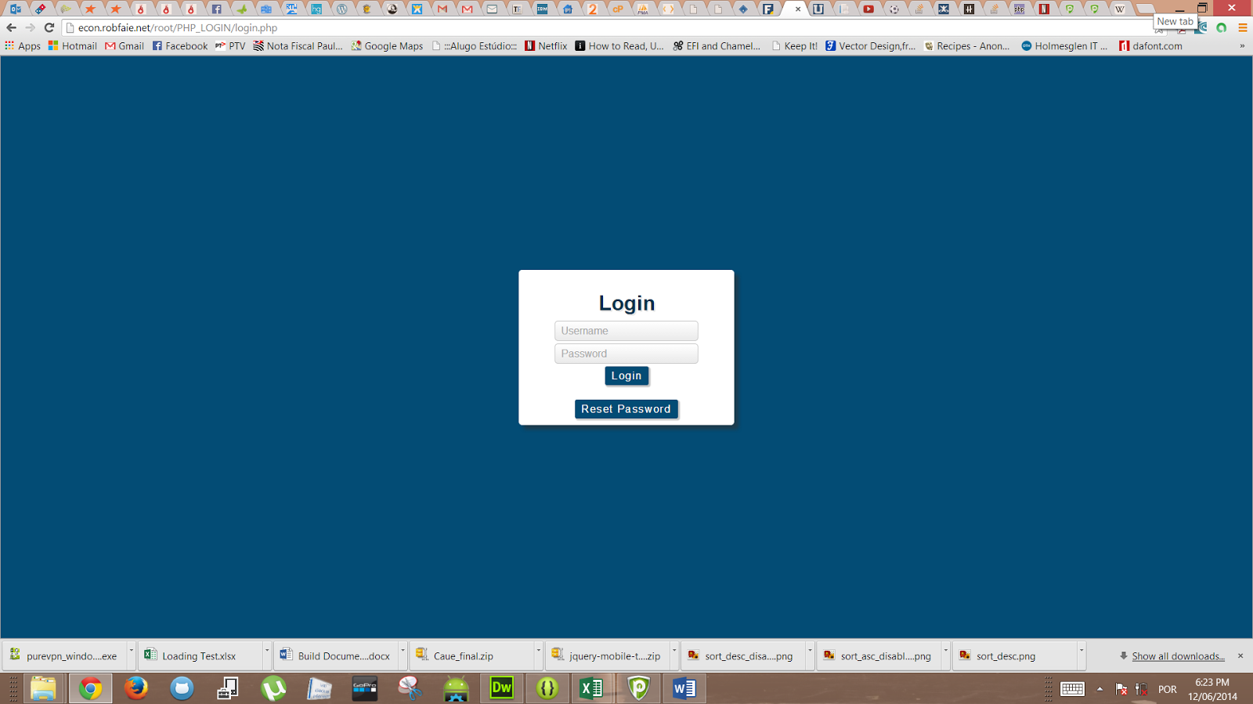

**Please use one of the following login user information in order to log in to the website:**

|  |  |
| --- | --- |
| Username | Password |
| Paul | **Password1** |
| Rudhra | **Password1** |
| Shuhei | **Password1** |
| Admin | **Password1** |

**After the login process, you should be greeted with this home screen.**

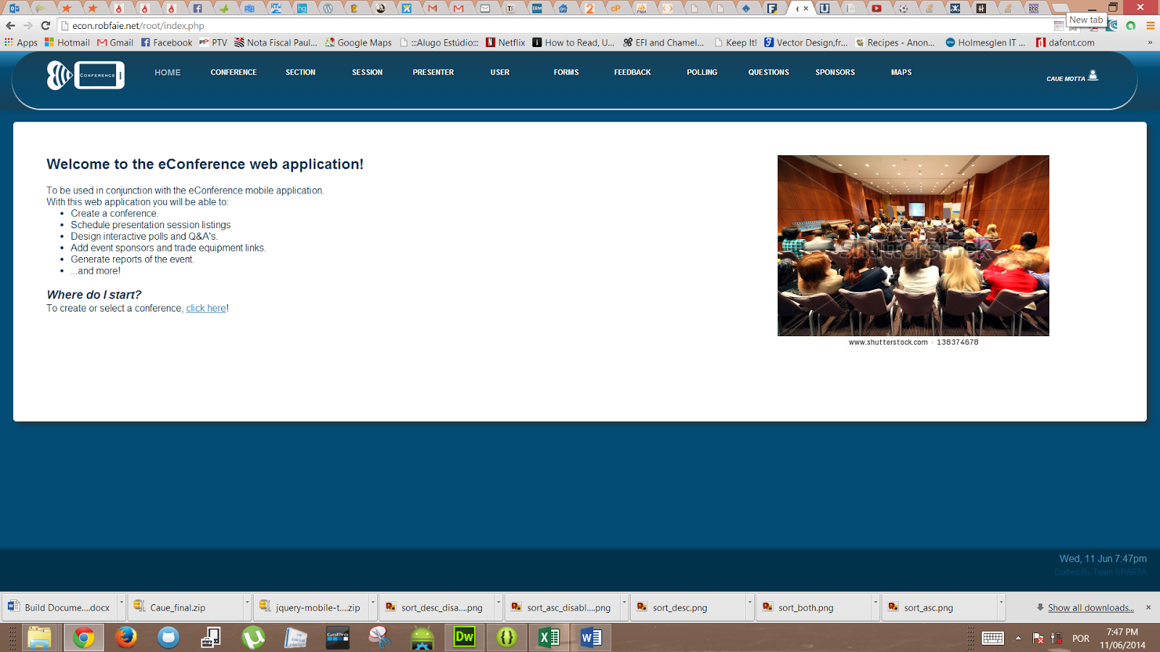

To get a feel for how this web app will operate, let's step through the process of viewing, adding, editing and deleting a new record in order to test your newly installed application.

Navigate to a view page.

**Using the ribbon navigation bar at the top of the page, select the Conference option.**

**You will be greeted with an overview of all records in the system.**

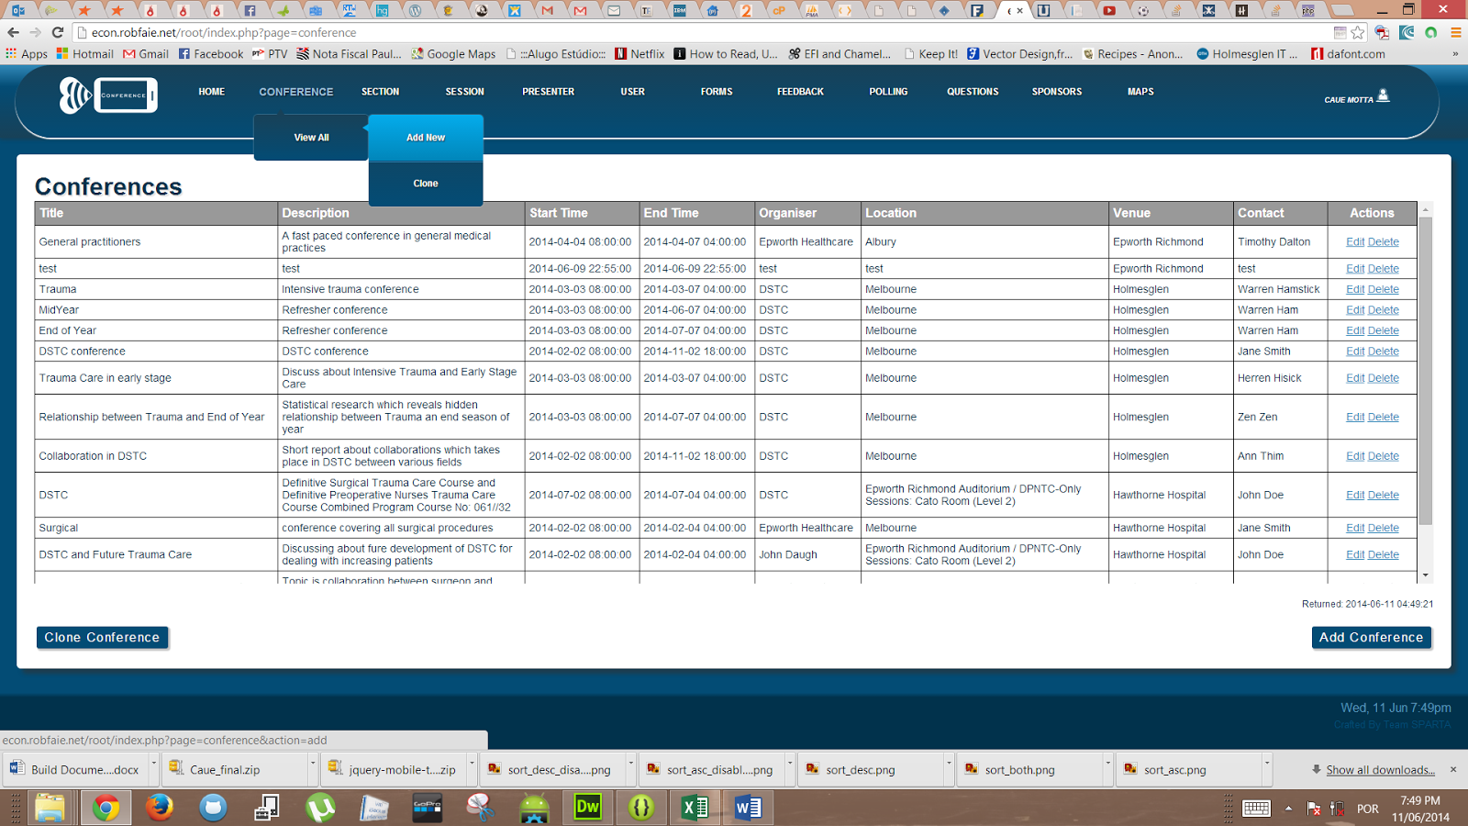

Our next step is to add a new record.

Click the "Add new" button to the bottom right of the table.

Adding a new record:

**Here we see the Add conference page.**

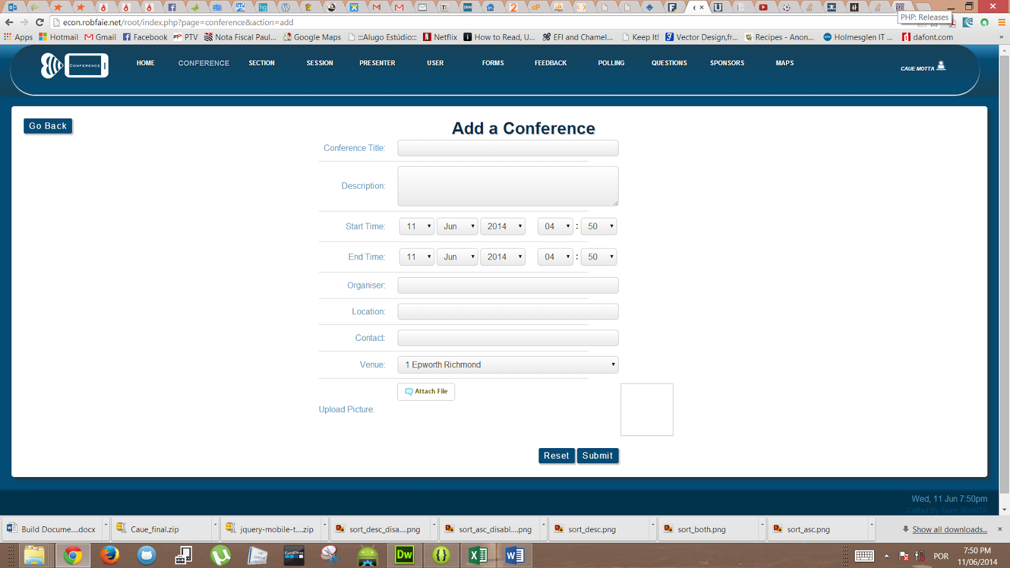

Let’s fill out the add conference form.

Here are some suggested values for testing (you can use your own):

Conference Id: TES1234

Title: A test conference

Description: A DSTC conference about trauma care and surgery in 2014.

Start time: Leave as is

End time: Change the date to 3 days later.

Organizer: DSTC

Location: Melbourne, Australia

Contact: Geoff

Venue: MLB2233 - Royal Melbourne Hospital

Next, click Submit. If all the entries are valid, you will be taken back to the view conferences screen, and your new conference will be visible.

In the case of one or more entries having invalid data, feedback will be given to you, with the opportunity to change the invalid fields and resubmit.

Next up is editing a record. Click the "edit" option in the Actions column of our new conference.

Editing a record.

**Here you can see an example of the editing screen.**

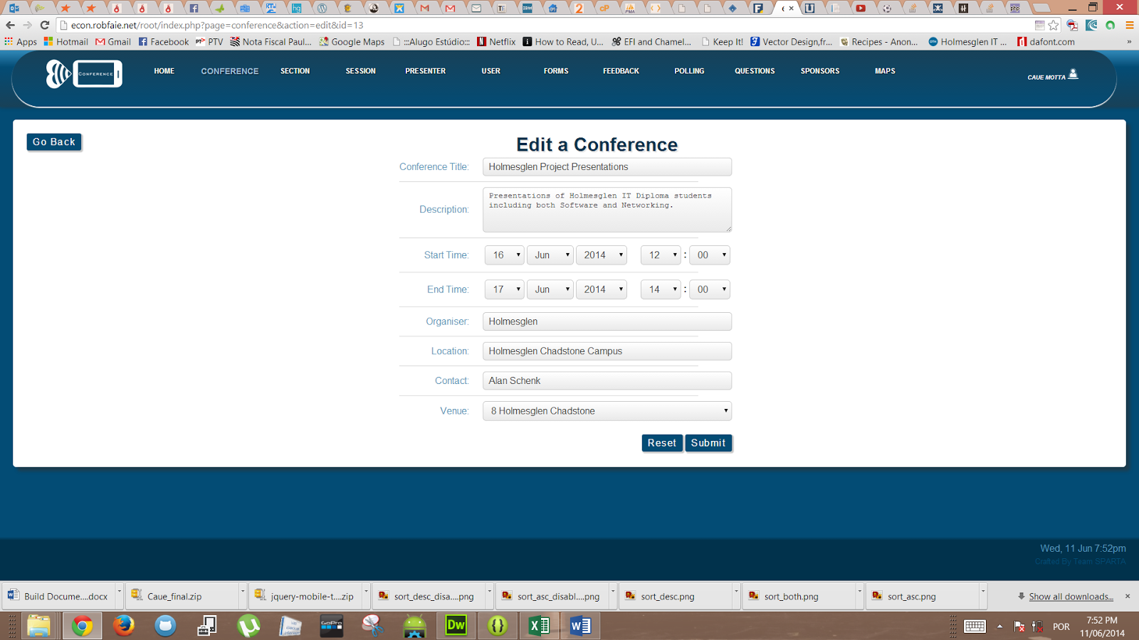

From this screen we can edit any of the entries in our newly created conference. Let’s do some editing now.

Suggested changes:

Conference Id to: CON2059

Organiser to: Epworth Medical

Contact to: Bob Uncle

Venue to: ALB1112 - Albury Medical Centre

Next, click Submit. If all the entries are valid, you will be taken back to the view conferences screen, and your new conference will be updated with the new information.

Like with the Add conference page, in the case of one or more entries having invalid data, feedback will be given to you, with the opportunity to change the invalid fields and resubmit.

Next up, we are going to delete the conference we just created and edited. Click the "delete" option in the Actions column of the view conferences page for the test conference.

Deleting a record

**This is how your deletion warning screen will look like:**

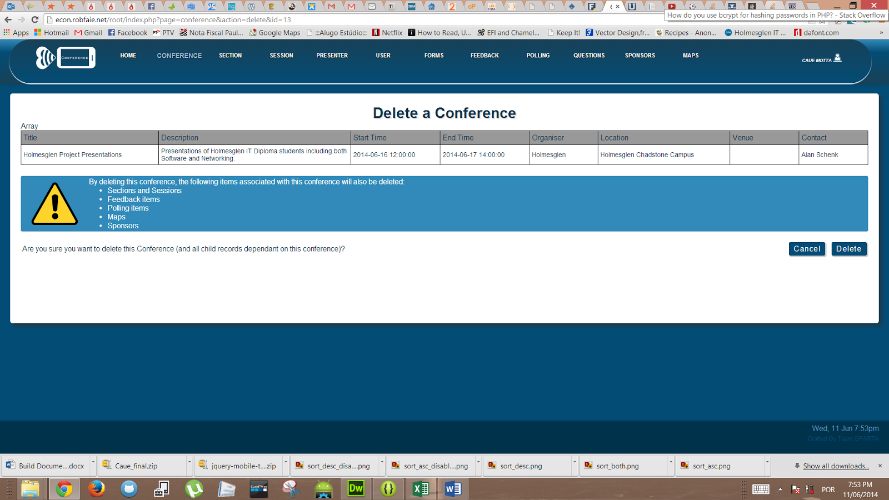

Before the conference is deleted, you are presented with a confirmation screen.

When a conference is deleted, so is all the information linked to that conference. You are warned about this on this confirmation page.

Click the delete button to proceed. You will be taken back the view conferences page, and the new conference is no longer in the system.

From here you should be familiar with the basic operation of the web application.

Thank you!

**We hope that your experience installing eConference was smooth and not at all stressful. Further on we wish you and all your eConference users to enjoy every bit of it as we have enjoyed the journey of developing it!**

**Have a nice conference!**